Impact Assessment of Britannia Nutrition Foundation’s CSR Programs
[Type the document subtitle]
Ankush Singh
Chief Development Officer
[Pick the date]

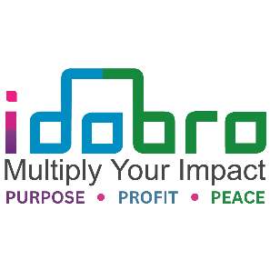

Idobro Impact Solutions
Ally Member – World Benchmarking Alliance (WBA)
Institutional Member of Community of Evaluators, South Asia (CoE-SA)
Member of Evaluation Community of India (ECOI)
Founder Member – ECOI Maharashtra Chapter
Member – South Asia Network of Impact Masters (SANIM)
Member – Society for Entrepreneurship Education (SEE)
Certified Women Owned Business – WEConnect International
Awardee – UN Women Women Empowerment Principles (WEP)

Registered Office: 121, East West Industrial Estate, Andheri-Kurla Road, Safed Pool, Mumbai – 400072
+91 22 6573 0776 | info@idobro.com | www.idobro.com

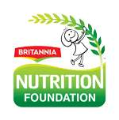
About Britannia Nutrition Foundation
Britannia Nutrition Foundation (BNF) is the social arm of Britannia. Set up in 2010 with the vision to help address malnutrition. Since its inception in 2010, Britannia Nutrition Foundation has focused on improving health and nutritional well-being of children and their communities. The programs are implemented through a multi-pronged approach that works at three levels:
(i) At the Anganwadi Centre level, the Foundation provides capacity building support to the Anganwadi workers, helpers and ASHA workers thereby enabling them to deliver quality nutrition and health services for children, expectant/new mothers, and adolescent girls.
(ii) At the Community level, to foster community's participation & ownership and through a behavior change-led intervention, the Foundation facilitates improvements in mothers' and caregivers' knowledge and practice of health, WASH and nutrition. Women are identified and trained to become community change agents
(iii) At the School level, by developing positive attitude and knowledge towards health, hygiene and nutrition practices, identifying and training adolescents to be Nutrition Champions.
The programmes are implemented in collaboration with the Integrated Child Development Services (ICDS) of the Department of Women & Child Development, Health & Education Department and other partners.

Study Objective
- To assess the impact of the BNF’s CSR programs and to identify the intended and unintended impact created and learnings from these programs for replication and/or scaling up

Support from BNF
The following support would be appreciated from BNF
- Dedicated SPOC: Appointing a SPOC for each program and location for smooth data collection and stakeholder engagement
- Stakeholder Information: Providing contact details and introductions to relevant stakeholders, including AWC, partners, beneficiaries, and government departments
- Beneficiary Coordination: Assisting in connecting with beneficiaries for streamlined data collection and engagement
- Program Documentation: Sharing program reports (baseline, midline, others) and beneficiary details in an easy-to-analyze format
- Health Records: Providing health records of children from AWC and existing data for comparative analysis
- Support to Identify resources: Providing support to identify research investigators to assist with the data collection
- Local language translation: Translating all documents into local language as required.

Assumptions
- Daily Local Travel Support: BNF will provide local travel support for daily data collection and stakeholder visits at all locations
- Comparative Analysis Clarification: The analysis will not include a comparative assessment between locations. If such analysis becomes necessary, adjustments to sample size and budget may be considered and revised accordingly.

Program Team Structure

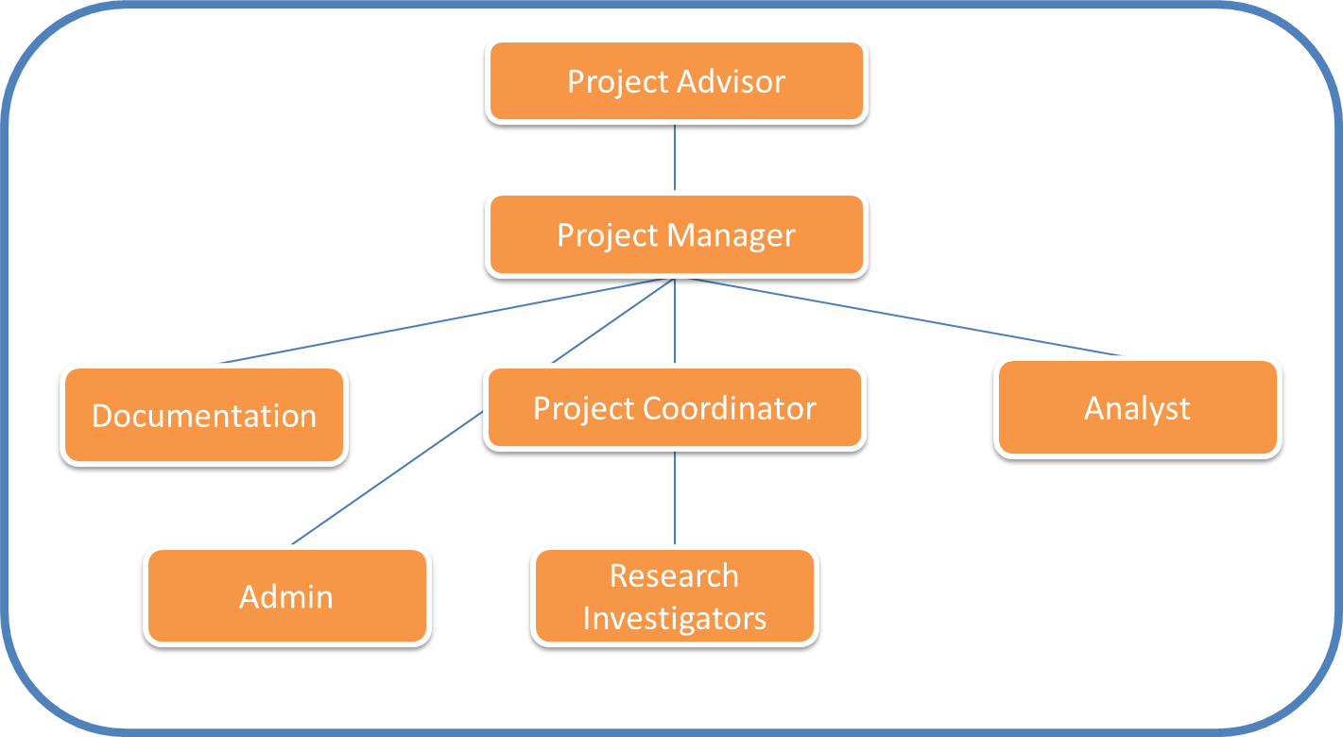

Other Projects
Project Description | Organization
Impact assessment of Partner NGO’s spread across India and in Kenya over 4 consecutive years. NGO Ranking Index designed for Partner Recognition  Communication Catalyst (SBCC), Nutrition Awards (3 years), Meri Pustik Rasoi (8 years) initiatives reaching 25 states of India | Glenmark Foundation  (15 years)
Design and development of a theory of change along with a detailed monitoring and evaluation framework to understand the impact of the Education & Health program on the lives of the school students in 19 tea gardens, Jalpaiguri, West Bengal and recommendations to scale it up. Financial Literacy programs across 21 states of India. Employee engagement initiatives | Tata Capital Financial Services Ltd.  (8 years)
Due Diligence of partner NGO’s for the “Star & Diya” Program thats supports NGO’s across India remotely for Educational and Health programs | Tata Trent Limited  (5 years)
Baseline and Endline assessments across multiple years and different programs to assess the change brought about by the School Leadership Development Intervention (SLDI) with over 100 school headmasters | Kotak Education Foundation (4 years)
CSR planning along with Impact Assessment study and Situation Analysis of projects across five states namely Karnataka, Maharashtra, Gujarat and Uttar Pradesh | Multi Commodity Exchange (MCX)  3 years
Developed a Community Perception Index in Maharashtra and Haridwar- Conducted over 3 years, the analysis provided valuable insights that shaped the company's overall program strategy and resulted in two regional coalitions and a Model School template for replication across geographies | Godrej Group  (3 years)
5 Country Needs Assessment Survey for VOPEs – Bangladesh, Bhutan, India, Nepal and Sri Lanka | CoE South Asia & Eval Partners (UN Chaired)
Design and development of a program on health and hygiene for school students followed by the implementation covering over 40,000 students in Ashramshalas | VVF Limited
Implementation of a Environmental Social Impact Assessment (ESIA) for Project funding of a Solar park in Gujarat (Charanka) which is spread over an area of 286 acres and a capacity of 65MW in line with World Bank regulations and the IFC standards along with community perception analysis. | Mahindra Susten

Terms & Conditions
- Fees - Total amount plus GST/taxes as applicable
- Extension / Scope––Change in requirements must be provided in writing. Extra efforts or cancellation of activities for which costs will be incurred to be borne by client. Management fees for any additional requirements over and above the scope at the start subject to approval
- Extras– All extra market research and field surveys, database generation and management, content writing, collateral design and production, event participation or management, vendor fees, PR, social media campaigns, publication inserts and subscription, media and digital fees as per project requirements. Idobro does not provide any databases or contact details of potential organizations. Background information or research information will only be shared as deemed necessary by Idobro
- Acknowledgement– Citation of the results or reports should be as “Impact Study & Analysis by Idobro” or as the Knowledge Partner in all forums and / or collateral.
- Payment– 50 % shall be paid on signing the contract, 30 % on completion of one month of data collection, 20% on submission of final report
- MOU – Non-exclusive, non-solicitation, confidentiality clauses mutually applicable
- Termination – One month written notice in advance.

https://www.britannia.co.in/article/britannia-nutrition-foundation-commemorates-11-years-of-improving-health-nutritional-outcomes-for-children-women

